Laboratory of Analytical Chemistry
Experiment No. (3):
Determination of the percentage of Acetic acid in a Vinegar sample

Aim of Experiment : To determine the w/v and the w/w percentages of acetic acid in vinegar bottle.

Introduction:-
Vinegar is essentially a solution of acetic acid (CH₃COOH ) in water. The acetic acid can be made naturally in a two –step process. Firstly converting the simple sugar (like glucose) into ethanol by the effect of yeast enzyme, and secondly, the conversion of ethanol into acetic acid by the action of acetic acid bacteria.

Chemical principle:
As with the previous two experiments, the chemical principle for this experiment is acid base- reaction.

NaOH +CH₃COOH → CH₃COONa +H₂O

Chemicals:
- Standardized NaOH solution (0.1N)
- Unknown Vinegar solution
- Distill Water
- Phenolphthalein (ph.ph) indicator
Safety :
We should be especially careful when handling the concentrated sodium hydroxide base solution (NaOH), as it is corrosive and can cause chemical burns to the skin. If any concentrated NaOH solution spills on anybody, he must rinse it immediately under running water for up to 15 minutes. The student he should report the accident to his instructor.

Procedure :

- Transfer 10 ml of unknown vinegar into 100 ml volumetric flask, complete the volume with distilled water, stopper the flask and shake well .
- With a graduated cylinder, transfer 10 ml of this diluted vinegar solution to a conical flask.
- Add 2 drops of (ph.ph) as an indicator.
- Rinse the burette with (0.1N) NaOH solution
- Fill the burette with (0.1N) NaOH solution .
- Be sure that there are no air bubbles in the tip of the burette.
- Titrate the prepared acetic acid solution ( diluted unknown ) with standard NaOH until the color of the indicator becomes faint pink.

Note : Phenolphthalein is a pH sensitive organic dye. Phenolphthalein is colorless in acidic solutions like vinegar, and deep pink in basic solutions like sodium hydroxide. At the equivalence point of the titration, just one drop of NaOH will cause the entire solution in the Erlenmeyer flask to change from colorless to a very pale pink.

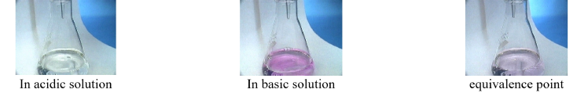

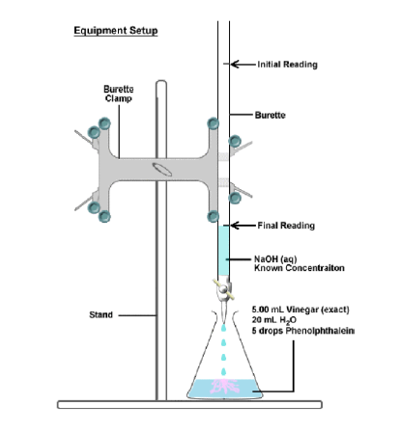
Calculation :

NaOH HAC
N₁ V₁ = N₂ V₂
N V _{(NaOH)} = $\frac{wt}{eq.wt}$ $×\frac{1000}{ V ml}×$ v _{ml}
N V _{(NaOH)} = $\frac{wt}{eq.wt}×$1000

Wt = $\frac{N ×V × eq.wt HAC}{1000}$
$$gm of acetic acid \left(HAC\right)in 10 ml of dilute unknown$$
This wt$×$ 10 = the wt of acetic acid in 10 ml concentrated vinegar solution.

To calculate the w/v and w/w perentages:
% wt /v of HAC = $\frac{wt (HAC)}{V (vinger)}$ $×$100

% wt/ wt of HAC = $\frac{wt of ( HAC)}{wt (vinegar) }$* 100

Notice : in order to get the weight of the vinegar itself ( acetic acid + water) which is needed in the above equation, we apply the following :
Wt (vinegar) = V _{(ml)} $×$ density of HAC
(Where density of the vinegar is gotten from the bottle and its usually $\sim 1.05$)

Hint/
CH₃COOH At.wt :- C = 12 , O = 16 , H =1
Eq.wt = $\frac{Mwt}{no of active H}$

Home Work :
1.Different vinegars may have different percentages of acetic acid. Is vinegar a mixture, compound, or an element?

2. Suppose you added 20 mL of water to your vinegar sample instead of 10 mL. Would the titration have required more, less or the same amount of (aq) for a complete reaction? Explain.

Lecturer
Raghad . J. Al- doghachi

